Figure 1: CT Abdomen Pelvis With Contrast- multiseptated cystic right adnexal mass measuring 5.8 x 5.1

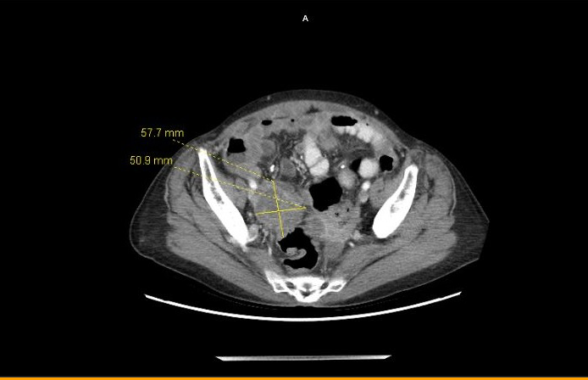

Figure 2: CT Abdomen/Pelvis- Diffuse multifocal loculated pockets of ascites throughout the abdominal cavity, with a multiseptated cystic right adnexal mass, concerning for metastatic ovarian carcinoma.

